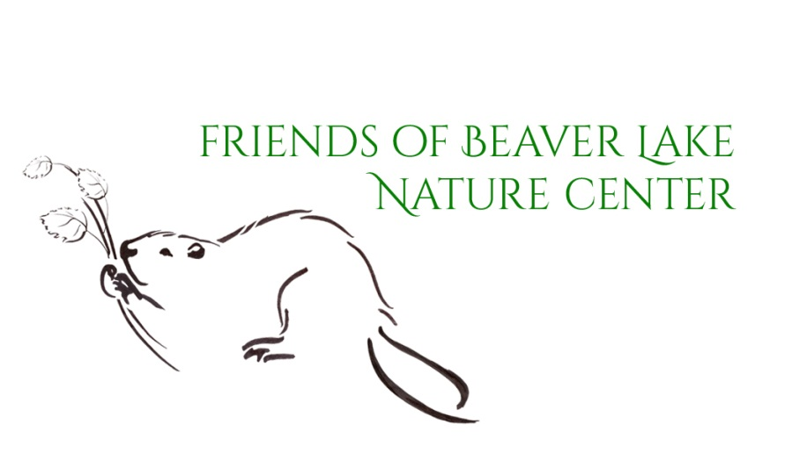

Field Trip Transportation Scholarships
This scholarship is for the cost of transportation for guided field trips only.
This does not include the cost of the guided tour.

Name of School Grade Level
Street Address Precise Number of Students
City State Zip Code
Area Code & Phone Number Number of Teachers
Fax Number Number of Chaperones
Email
Teacher Name
Date of Visit Numbers of Buses Required
Arrival Time Total Cost of Buses
Scholarship should be made out to:
School name or district
Please include a letter of support from your principal. This letter should include the reason for requesting the scholarship (budget cuts, etc.). Send the letter and completed application form and mail, fax, or email to:

Beaver Lake Nature Center
8477 East Mud Lake Road
Baldwinsville, NY 13027
Email: blnc@ongov.net
Fax: (315) 638-7488
Your application will be reviewed and a notification (approval or rejection) sent within 2 weeks of receiving the completed application. If you receive a scholarship, your school will be reimbursed within 2 weeks after your visit.

